# **Sir Syed University of Engineering & Technology (SSUET)**

# **Software Engineering Department**

***Course Name: Data Structures & Algorithm (SE-203L)***

***Semester: 3rd***

***Batch: 2023F***

***Section: B***

**PROJECT REPORT**

***Project Title: Fitness Goal Tracker***



***Submitted To:***

***Engr. Dur-e-Shawar Agha***

***Engr. Sara Gohar***

***Submitted By:***

**MUHAMMAD SHAYAN AHMED 2023F-SE-088**

**MUHAMMAD SHAHZIL 2023F-SE-327**

**MUHAMMAD EZAAN 2023F-SE-081**

**SUHAIB 2023F-SE-063**

**TABLE OF CONTENTS**

|  |  |  |
| --- | --- | --- |
| S.No. | TOPIC | Page No. |
| 1 | INTRODUCTION OF THE PROJECT | #4. |
| 2 | ALGORITHM / PSEUDOCODE OF EACH OPERATION | #6. |
| 3 | PLAN OF WORK | #7. |
| 4 | PROJECT SCHEDULING | #10. |
| 5 | DATA STRUCTURES USED IN PROJECT | #11. |
| 6 | BLOCK DIAGRAM | #12. |
| 7 | SYSTEM FLOW DIAGRAM | #13. |
| 8 | USER GUIDE | #14. |
| 9 | CONCLUSION | #18. |
| 10 | FUTURE EXPANSION OF THE PROJECT | #19. |

TEAM PROFILE

1. **MUHAMMAD SHAYAN AHMED (2023F-SE-088)**

GROUP LEADER

1. **MUHAMMAD SHAHZIL (2023F-SE-327)**

Team member

1. **MUHAMMAD EZAAN (2023F-SE-081)**

Team member

1. **SUHAIB (2023F-SE-063)**

Team member

## 1. INTRODUCTION OF THE PROJECT

**Project Title: Fitness Goal Tracker**

**Description:**

The Fitness Goal Tracker is a desktop application designed to help users efficiently manage their fitness journey. It offers features such as tracking personal information, managing exercise routines, calculating BMI, and visualizing progress. With an intuitive interface and effective data management, the system is ideal for fitness enthusiasts, trainers, and individuals aiming for a healthier lifestyle.

**The Need for the Project:**

1. **Health Awareness:** Growing health issues such as obesity, heart conditions, and a sedentary lifestyle have created a demand for fitness solutions.
2. **Personalized Fitness Management:** Users need a platform that allows them to log and track their personal fitness data and customize their exercise plans.
3. **Accessible Tracking Tools:** Many individuals need simple tools to calculate BMI, set fitness goals, and monitor their progress over time.
4. **Centralized System:** Users want an all-in-one system to store their exercise history, monitor body metrics, and visualize improvements without using multiple tools.

**Context:**

In today's fast-paced world, maintaining physical fitness has become a necessity. However, many individuals struggle to track their progress and manage their fitness activities effectively. Existing fitness solutions often lack personalization or are too complex for everyday users. This project bridges that gap by providing a user-friendly and customizable system that caters to fitness tracking and management needs.

**Objectives:**

1. **User Information Management:**
   * Enable users to update and maintain their personal information such as name, age, gender, height, weight, and body type.
2. **Exercise Tracking:**
   * Allow users to log and track various exercises with their duration, type, and frequency.
3. **BMI Calculator:**
   * Provide a built-in tool to calculate Body Mass Index (BMI) and offer health recommendations based on the results.
4. **Progress Monitoring:**
   * Implement features to visualize user progress through data history, graphical representations, and milestones.
5. **Efficiency and Accessibility:**
   * Design the system to be fast, reliable, and easy to use for users with minimal technical expertise.
6. **Action Recommendations:**
   * Suggest exercises and routines based on user fitness levels and goals.
7. **Scalability:**
   * Ensure the system can handle increasing amounts of data and users as the need grows.

**Significance of the Project:**

The Fitness Goal Tracker offers users an innovative and comprehensive way to manage their health goals. By combining ease of use with powerful tracking and analysis tools, the project aims to promote healthier habits, improve fitness levels, and contribute to a better quality of life for its users. This project is not only a tool for managing fitness but also a step towards encouraging more people to lead a healthy and active lifestyle.

## 2. ALGORITHM / PSEUDOCODE OF EACH OPERATION

Here’s an overview of common operations along with their algorithm or pseudocode:

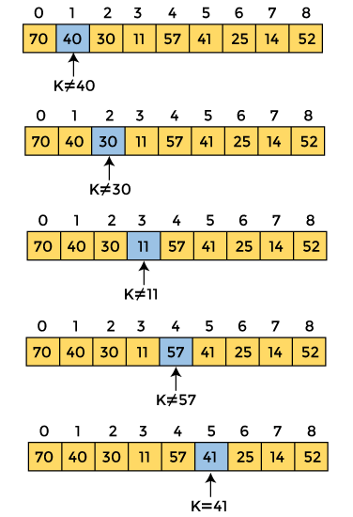**Linear Search (For searching required data in array):**

* Set Flag = 1
* Repeat Step 3 for k = 0,1,2, ---N-1
* If L[K] == ITEM then

1. Set Flag == 0
2. Write k

* If Flag == 1 while “Search Unsuccessful”
* Exit

**Selection Sorting (For sort the members names alphabetically):**

* Set M = L – 1
* While M > 0

Find largest element

Swap element with marker location

* M = M - 1

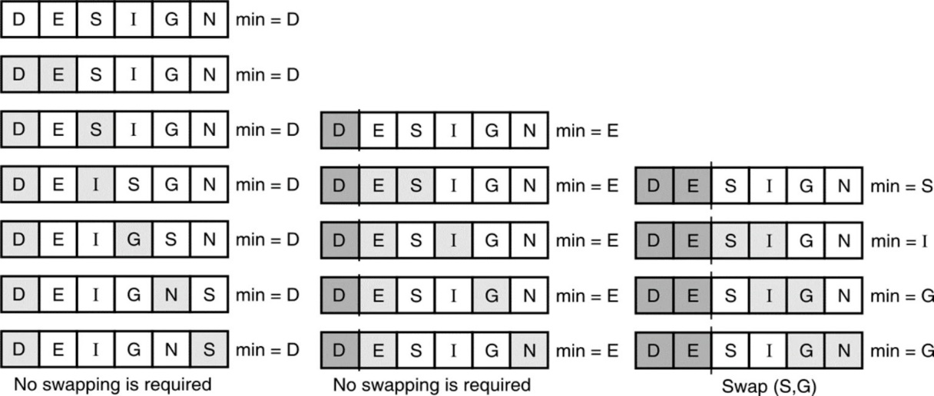

## 3. PLAN OF WORK

To successfully complete the **Fitness Goal Tracker** project, the work has been divided into multiple tasks, with specific responsibilities assigned to each of the 4 team members. The tasks are structured to ensure effective collaboration, timely progress, and quality results.

**Project Tasks and Assignments:**

1. **Requirement Analysis**
   * **Description:** Gather and analyze the project requirements by identifying the features, functionalities, and target users of the system. Outline the necessary software and hardware specifications.
   * **Responsible Member(s):** Muhammad Shayan Ahmed.
   * **Expected Output:**
     + Requirement Specification Document
     + Functional and Non-Functional Requirements
2. **System Design**
   * **Description:** Develop the system architecture based on the requirements, including designing workflows, data flow diagrams, and database schema. Create a detailed plan for implementing the data structures.
   * **Responsible Member(s):** Muhammad Ezaan, Muhammad Shahzil.
   * **Expected Output:**
     + System Architecture Diagram
     + Workflow and Data Flow Diagrams
     + Database Schema
3. **Front-End Development**
   * **Description:** Develop the user interface (UI) for the application, including the login page, dashboard, and forms (e.g., Update User Info, Exercise Tracker).
   * **Responsible Member(s):** Muhammad Shayan Ahmed, Muhammad Shahzil, Suhaib.
   * **Expected Output:**
     + Intuitive Login Page
     + User-Friendly Dashboard
     + User and Exercise Management Screens
4. **Back-End Development**
   * **Description:** Implement the core functionalities such as user authentication, BMI calculation, exercise tracking, and fitness goal tracking using data structures like arrays, stacks, queues, and trees.
   * **Responsible Member(s):** Muhammad Shayan Ahmed, Muhammad Shahzil, Muhammad Ezaan ,Suhaib.
   * **Expected Output:**
     + Functional Back-End for BMI and Goal Tracking
     + Exercise and Progress Data Handling
     + Integration with Front-End
5. **Database Development**
   * **Description:** Design, create, and manage the database for storing user details, fitness goals, exercise logs, and progress reports.
   * **Responsible Member(s):** Muhammad Shayan Ahmed, Muhammad Shahzil.
   * **Expected Output:**
     + Normalized Database Design
     + Query Scripts for Data Storage and Retrieval
6. **Integration and Testing**
   * **Description:** Integrate front-end, back-end, and database components; test the system for bugs, errors, and usability issues.
   * **Responsible Member(s):** Suhaib, Muhammad Shayan Ahmed.
   * **Expected Output:**
     + Fully Functional Integrated System
     + Test Cases and Debugging Reports
7. **Documentation**
   * **Description:** Prepare complete project documentation, including user manuals and technical details.
   * **Responsible Member(s):** Muhammad Ezaan, Muhammad Shayan Ahmed.
   * **Expected Output:**
     + Final Project Report
     + User Guide

**Timeline:**

1. **Week 1-2:** Requirement Analysis and System Design
2. **Week 3-4:** Front-End and Back-End Development
3. **Week 5:** Database Development
4. **Week 6:** Integration and Testing
5. **Week 7:** Final Documentation

## 4. PROJECT SCHEDULING

Project scheduling is the process of organizing tasks, resources, and timelines to ensure the timely completion of a project.

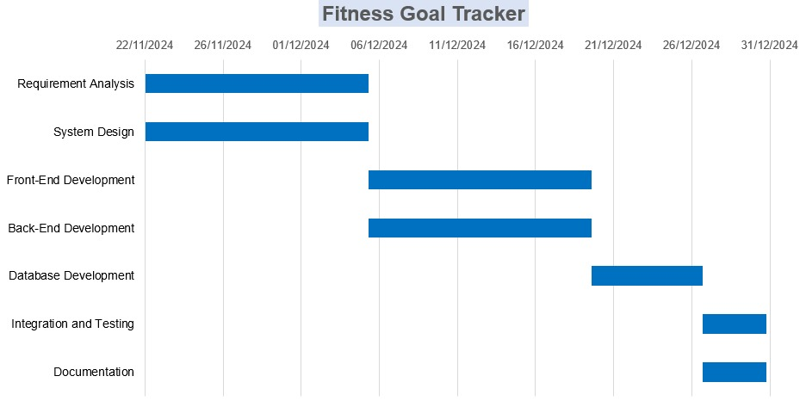

## 5. DATA STRUCTURES USED IN PROJECT

Mention all the data structures used in the project.

1. **Tree:**

This app uses the tree data structure to connect pages. The home page essentially is the root node for the different pages of the whole app with the other windows being the child nodes for the home page. Some child nodes like “user info” and “list of exercises” page have their own child nodes with “update info” and different categories of exercises respectively. This allows the traversing of different windows from home page.

1. **Linked List:**

The different categories of exercises are essentially a part of linked list. Each category of exercises links to a different category and each exercise stored in category links to a URL for its description. This allows traversing of different exercises as well as their details to search for.

1. **Array:**

The array data structure is a versatile and efficient way to manage collections of data in the Fitness Goal Tracker application. Its fixed size and direct indexing capabilities make it suitable for storing user logs, metrics, and recommendations, thereby enhancing the application's performance and user experience. By leveraging arrays, the application can efficiently handle and process the data necessary for users to track and manage their fitness journeys effectively.

1. **Stack:**

The stack data structure is a powerful tool that can enhance the functionality of the Fitness Goal Tracker application by providing features like undo capabilities, navigation history, and efficient management of recent activities. Its LIFO nature makes it particularly suitable for scenarios where the most recent actions or data points are of primary interest.

## 6. BLOCK DIAGRAM

Below is a sample block diagram. Make one for your project that should clarify overall concepts of your project. The principal parts or functions should be represented by blocks connected by lines that show the relationships of the blocks.

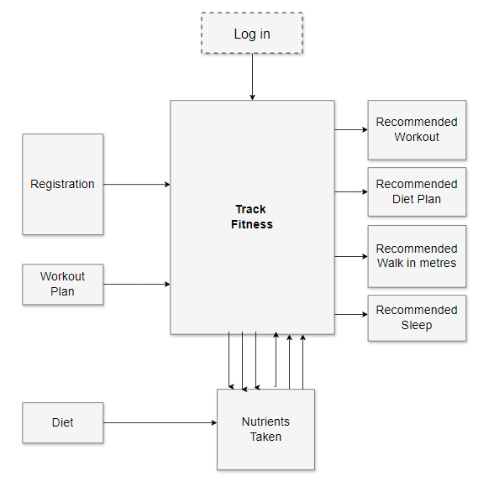

## 7. SYSTEM FLOW DIAGRAM

A **System Flow Diagram (SFD)** visually represents the flow of data and processes within a system.

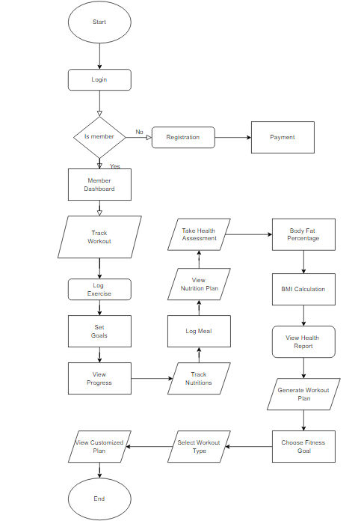

## 8. USER GUIDE

The Fitness Goal Tracker user guide provides step-by-step instructions to help you easily navigate and utilize the application's features. From updating your profile to tracking exercises and calculating BMI, this guide ensures smooth and efficient experience in managing your fitness journey.

**1. Login Screen**

* **Step 1**: Open the **Fitness Goal Tracker** application.
* **Step 2**: The login screen will prompt the user to enter their **Username** and **Password**.
* **Step 3**: Click the **Login** button to authenticate the user.
* **Step 4**: If the credentials are correct, the user will be redirected to the **Welcome Dashboard**.

**Screenshot**: Login screen with fields for username and password.

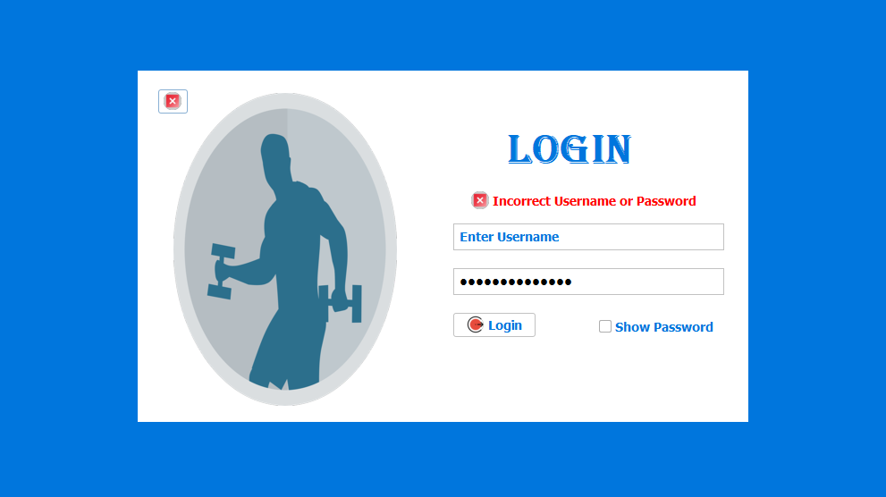

**2. Welcome Dashboard**

* **Step 1**: After logging in, the user is taken to the dashboard. Here, they can see the following options:
  + **Update Profile**
  + **Exercises list**
  + **BMI Calculator**
* **Step 2**: The user can select any option to navigate to the desired feature.

**Screenshot**: Dashboard with buttons/links to various sections.

**3. Updating User Information**

* **Step 1**: Click on **Update Profile** from the dashboard.
* **Step 2**: The user can update their **Name**, **Age**, **Height**, **Weight**, and **Body Type**.
* **Step 3**: After making the changes, click **Save** to update the profile.
* **Step 4**: A confirmation message will appear, stating that the profile has been successfully updated.

**Screenshot**: Form to update user profile information.

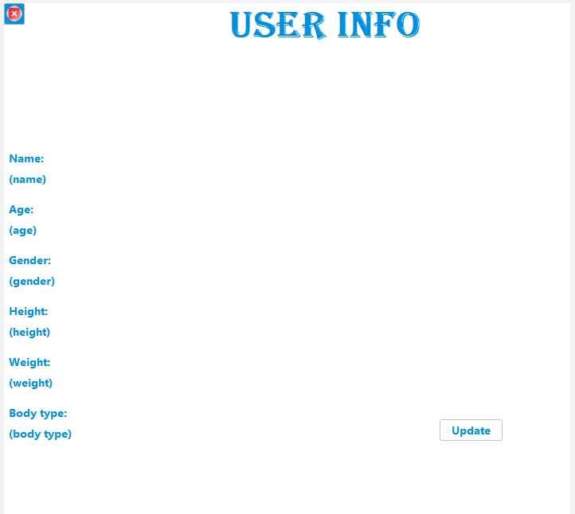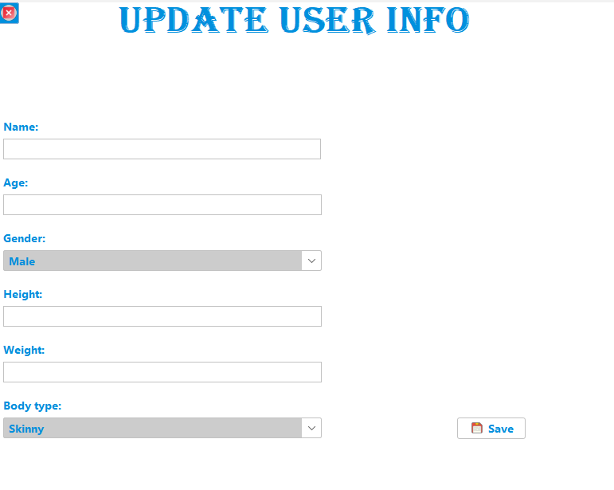

**4. Tracking Exercises**

* **Step 1**: From the dashboard, click **Track Exercise**.
* **Step 2**: A list of exercises appears. The user can select an exercise and enter details such as **Duration** and **Frequency**.
* **Step 3**: Click **Log Exercise** to save the exercise data.
* **Step 4**: The exercise is logged in the system, and the user can view the exercise history.

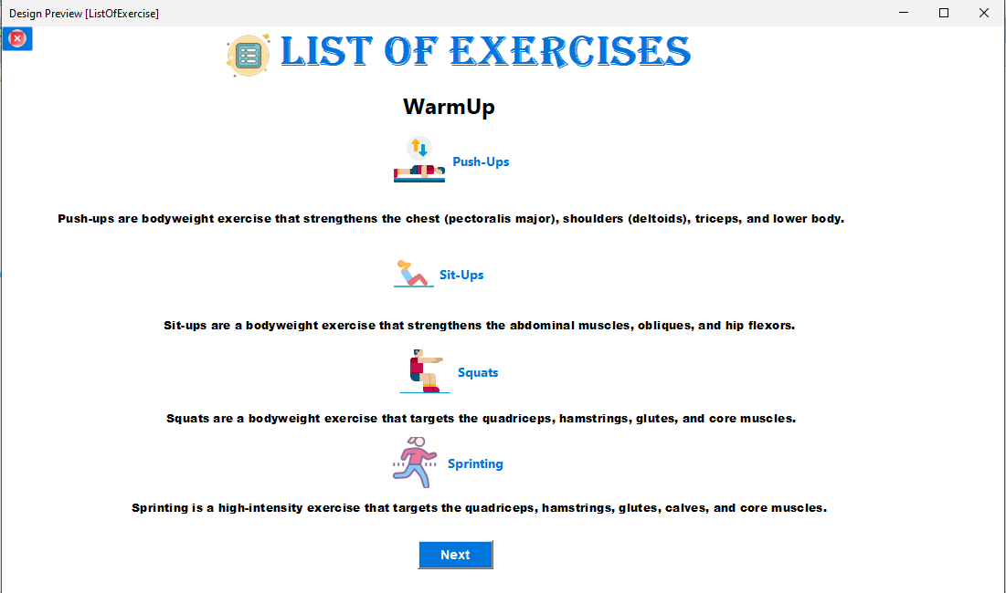**Screenshot**: Exercise list and form to input exercise details.

**5. BMI Calculator**

* **Step 1**: From the dashboard, click **BMI Calculator**.
* **Step 2**: The user is prompted to enter their **Height** and **Weight**.
* **Step 3**: After entering the details, click **Calculate BMI**.
* **Step 4**: The BMI value is displayed, along with a health recommendation (e.g., underweight, normal, overweight, etc.).

**Screenshot**: BMI calculation form and results screen.

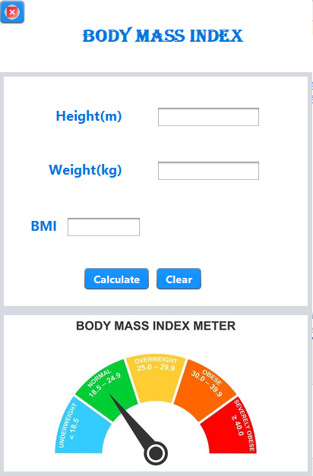

**6 Logging Out**

* **Step 1**: To log out, click the **Logout** button, typically located in the top-right corner.
* **Step 2**: The system will ask for confirmation.
* **Step 3**: After confirmation, the user will be logged out and redirected to the login screen.

**Screenshot**: Logout confirmation prompt.

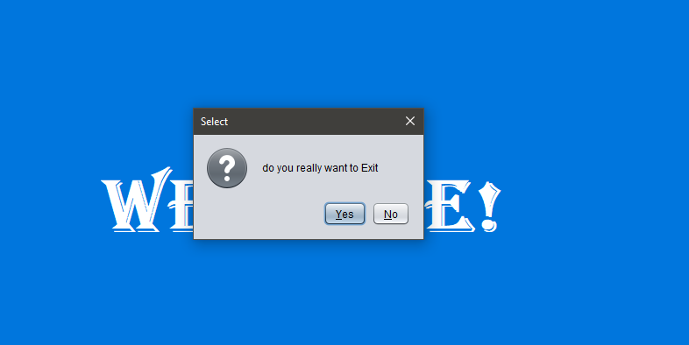

This user guide should assist end-users in navigating and utilizing the **Fitness Goal Tracker** effectively. Adding screenshots for each step will further enhance clarity for users.

## 9. CONCLUSION

The **Fitness Goal Tracker** project successfully provides a comprehensive solution for individuals seeking to manage and track their fitness progress. By integrating essential features such as personalized user profiles, exercise tracking, BMI calculation, and progress visualization, the system helps users stay motivated and focused on their health goals. The project demonstrates the power of efficient data management and user-friendly design, making it an invaluable tool for fitness enthusiasts. Moving forward, the application has the potential for scalability, allowing for further enhancements such as advanced fitness analytics and more personalized recommendations.

## 10. FUTURE EXPANSION OF YOUR PROJECT

The **Fitness Goal Tracker** has significant potential for future expansion and enhancement. Some of the planned features include:

1. **Integration with Wearables and Fitness Devices**: To provide real-time data on activities such as steps, heart rate, and calories burned, integrating with devices like fitness trackers or smartwatches will improve accuracy and personalization.
2. **Advanced Analytics and Reports**: Introducing detailed analytics to track long-term fitness progress, providing insights into trends, performance improvements, and goal achievements, will enhance user experience.
3. **Social and Community Features**: Adding social features such as the ability to share progress, participate in challenges, and interact with other users can increase engagement and motivation.
4. **AI-Based Recommendations**: Implementing machine learning algorithms to suggest personalized workouts and diet plans based on users' progress, preferences, and goals.
5. **Mobile App Version**: Expanding the platform to mobile devices, enabling users to access and track their fitness goals on the go, ensuring greater accessibility and convenience.
6. **Gamification**: Adding gamified elements such as achievements, badges, and rewards to encourage users to complete workouts and reach milestones will make the system more engaging.

These enhancements will ensure that the **Fitness Goal Tracker** evolves to meet the growing needs of its users and adapts to the latest trends in health and fitness technology.